DBMS ASSIGNMENTS 5, 6 & 7
SQL Querying, Aggregation & Joins
Student: Sasanka Sekhar Kundu
Assignment 5 — SQL Querying
Aim
To practice SQL querying on orderdb using filtering, sorting, date ranges, pattern matching, and comparison operators.
Database Used
PostgreSQL database: orderdb. Tables used: customers, products, and orders.
Queries Covered
Q1 Indian customers sorted by name.
Q2 Electronics products priced above 10000, sorted by price descending.
Q3 Orders from January 2024.
Q4 Non-India customers.
Q5 Products starting with L or belonging to Stationery.
Q6 Orders with quantity greater than 1, sorted by order date.
Result
The Part A queries executed successfully and returned the expected filtered and sorted records.
Submission Note
The submitted screenshots currently show the placeholder YOUR_ROLL_NO. Replace it with the actual roll number before final submission because the assignment requires the name and roll number to be visible in every screenshot.
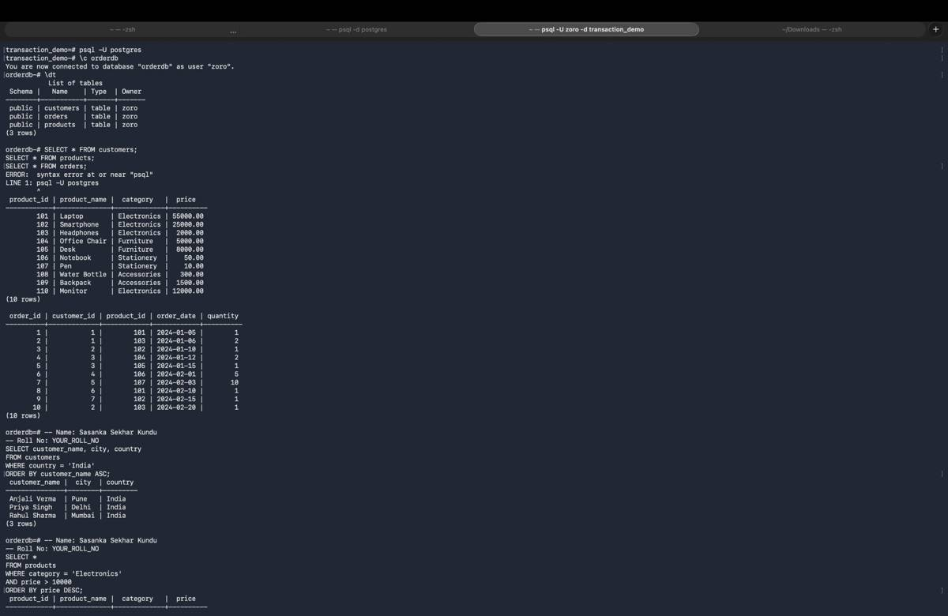
Screenshot 1 — Terminal execution evidence
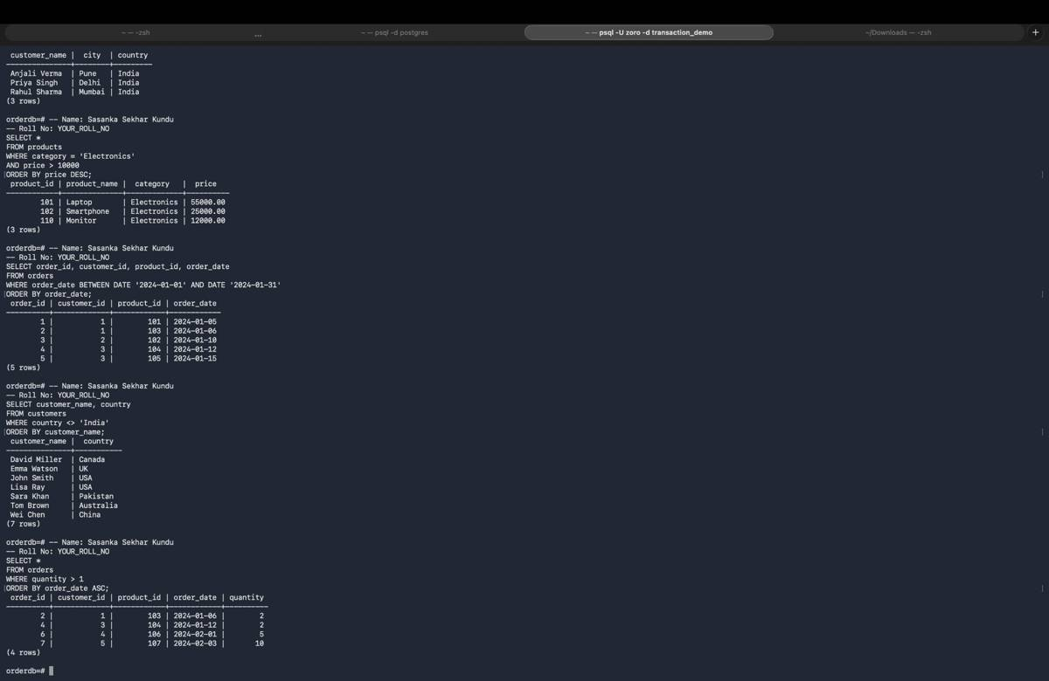
Screenshot 2 — Terminal execution evidence

Assignment 6 — Aggregation
Aim
To practice SQL aggregation using SUM, COUNT, AVG, GROUP BY, HAVING, subqueries, and date extraction.
Queries Covered
Q1 Total quantity per product.
Q2 Customers with more than one order.
Q3 Total revenue per product category.
Q4 Average product price per category, high to low.
Q5 Customer(s) with the maximum number of orders.
Q6 Total quantity for each month.
Result
The aggregation queries produced grouped quantities, order counts, category revenue, average prices, maximum-order customers, and monthly totals.
Submission Note
The submitted screenshots currently show the placeholder YOUR_ROLL_NO. Replace it with the actual roll number before final submission because the assignment requires the name and roll number to be visible in every screenshot.
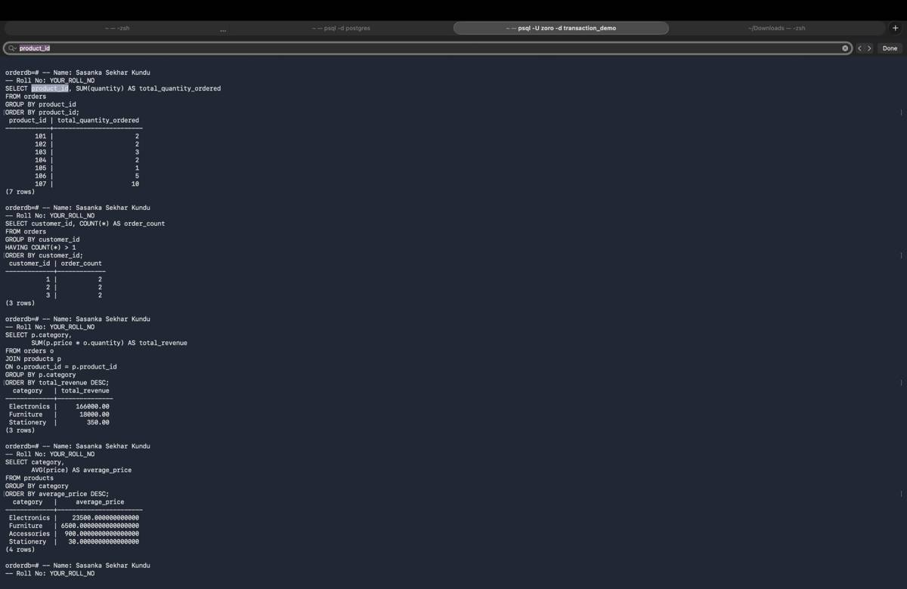
Screenshot 1 — Terminal execution evidence
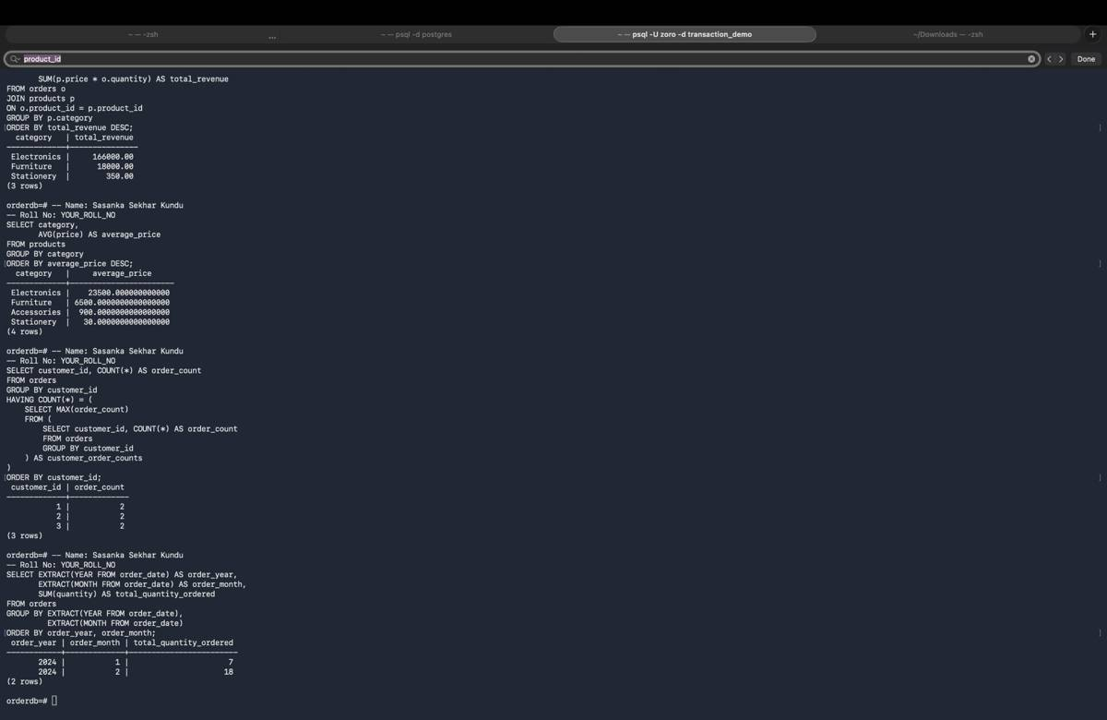
Screenshot 2 — Terminal execution evidence

Assignment 7 — SQL Joins
Aim
To practice INNER JOIN, LEFT JOIN, CROSS JOIN, multi-table joins, grouping after joins, and finding customers with no orders.
Queries Covered
Q1 INNER JOIN customers, products, and orders.
Q2 LEFT JOIN customers with orders, including customers without orders.
Q3 LEFT JOIN products with orders, including never-ordered products.
Q4 CROSS JOIN customers and products and determine row count.
Q5 Total revenue per customer using joins and aggregation.
Q6 Customers who have never placed an order using LEFT JOIN and IS NULL.
Observed Result
The CROSS JOIN produced 100 rows, corresponding to 10 customers × 10 products. The other joins demonstrate matched records, preservation of unmatched records with LEFT JOIN, revenue aggregation, and identification of customers with no orders.
Submission Note
The submitted screenshots currently show the placeholder YOUR_ROLL_NO. Replace it with the actual roll number before final submission because the assignment requires the name and roll number to be visible in every screenshot.
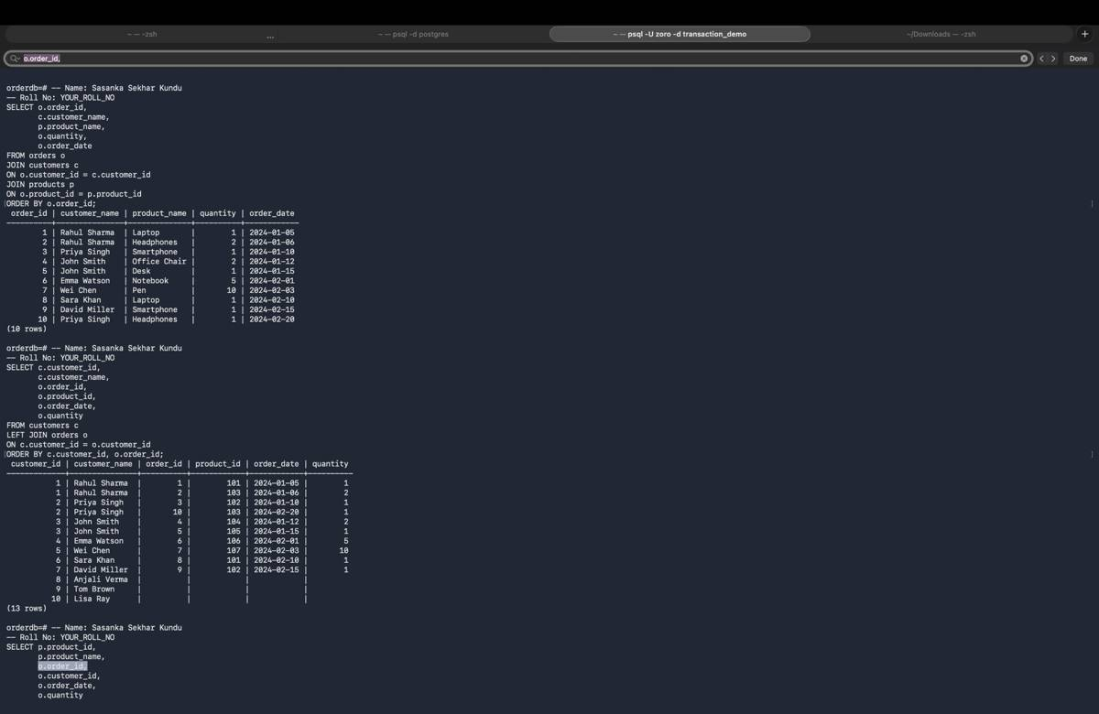
Screenshot 1 — Terminal execution evidence
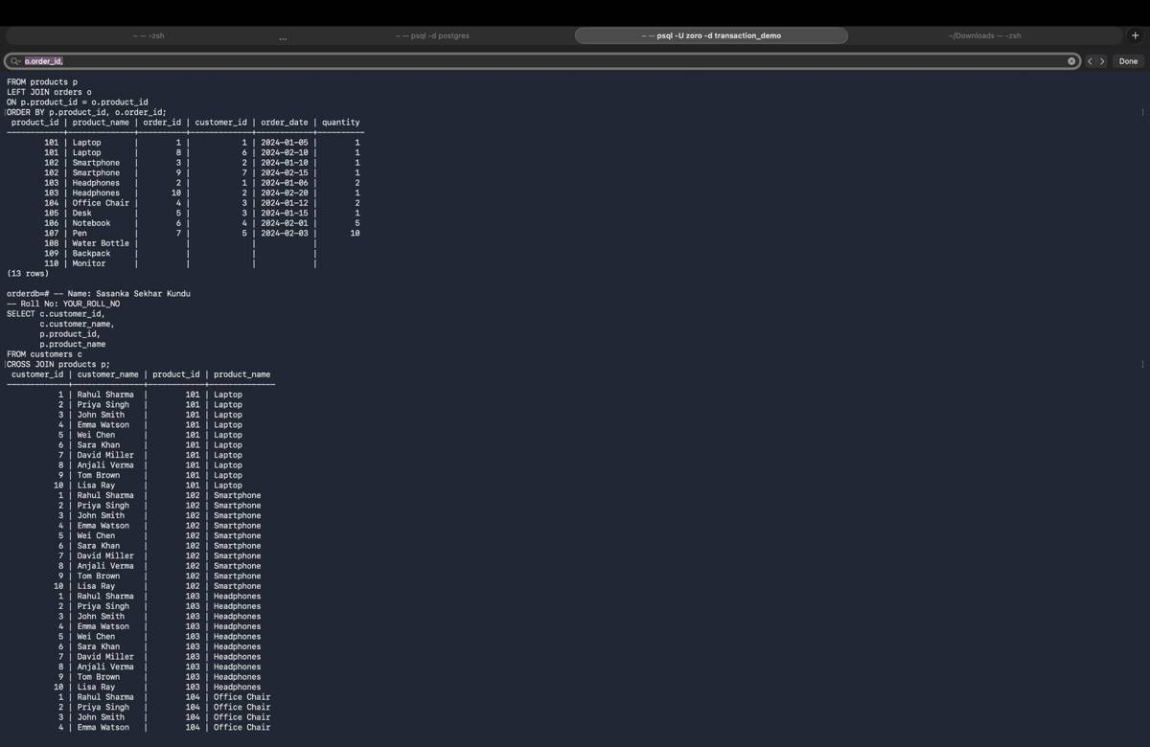
Screenshot 2 — Terminal execution evidence
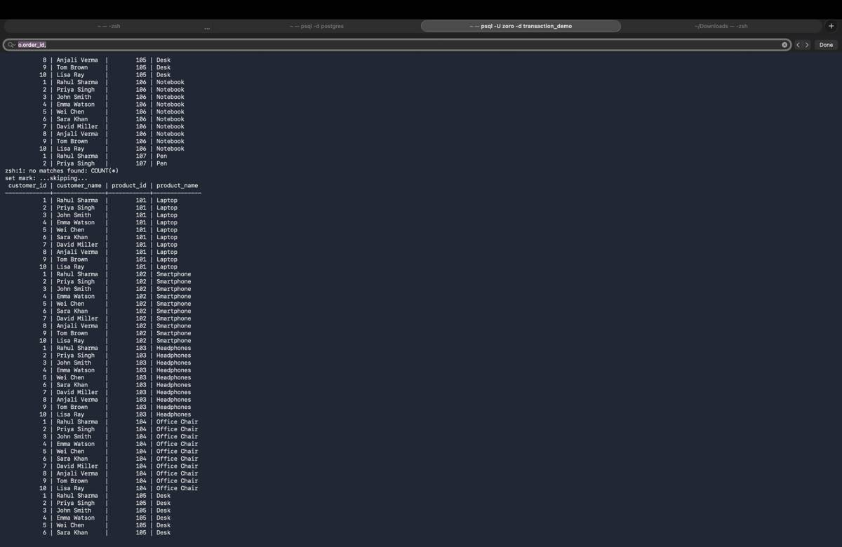
Screenshot 3 — Terminal execution evidence
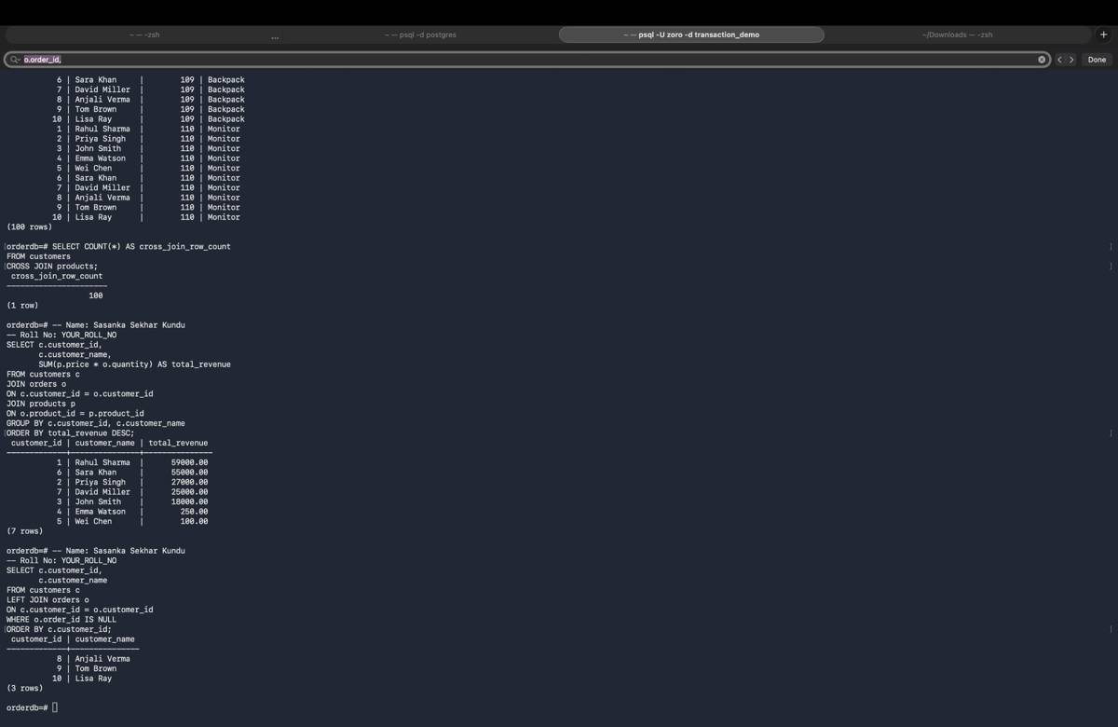
Screenshot 4 — Terminal execution evidence

